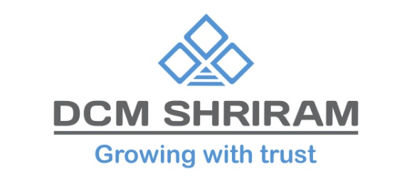

DCM Shriram Ltd. Secures Rs 100 Crore Sustainable Finance Facility from Standard Chartered Bank, India
New Delhi, 10th April 2024 - DCM Shriram Ltd, a leading conglomerate with diverse business presence in Chlor-Vinyl, Agri-Rural, and Value Added Businesses, proudly announces the successful tie up of its sustainable finance facility in the form of transition finance of Rs 100 crores from Standard Chartered Bank, India to fund its upcoming 12 TPD Compressed Bio Gas (CBG) Plant at Ajbapur Sugar Unit in the state of U.P.
This investment further reinforces the company’s commitment towards circular economy and sustainability. CBG will be produced using ‘Pressmud’ as a feed stock – a waste generated in the sugar manufacturing process. The state-of-the-art plant has been designed as a Zero Effluent Discharge Plant.
Mr. Amit Agarwal, Executive Director & Group CFO of DCM Shriram Ltd, said, "This is our second sustainable finance transaction in last 6 months, which underscores our unwavering commitment to assimilating ESG principles into our business philosophy and driving positive impact while generating value for our stakeholders. This also underpins our belief that Business success goes hand to hand with environmental stewardship, embodying our commitment to a more sustainable future.”

Shobana Chawla, Executive Director, Sustainable Finance, Standard Chartered Bank, India, said, “Sustainable financing continues to be one of the strategic priorities at Standard Chartered Bank. We have been assisting our clients transition to net zero, and at a group level have committed to mobilise USD 300 billion in Sustainable Finance by 2030. This facility to DCM Shriram is one such initiative..”
This collaboration between DCM Shriram Ltd and Standard Chartered Bank signifies a shared commitment towards fostering sustainability and responsible business practices, further solidifying their dedication to more responsible future.
About DCM Shriram Ltd:
DCM Shriram Ltd. is a leading business conglomerate with business portfolio comprising of primarily Chlor-Vinyl Business – Caustic Soda, Chlorine, Calcium Carbide, Aluminum Chloride, PVC Resins, PVC Compounds, Power and Cement; Agri-Rural Business – Sugar including distilleries, Farm Solutions, Urea, and Hybrid Seeds; and Value Added Business Fenesta Building Systems - UPVC & Aluminum Doors and Windows.
About Standard Chartered Bank
Standard Chartered Bank has been operating in India with a continuous presence of 170 years making it one of the oldest foreign banks in the country. The Bank has a network of 100 branches across 42 cities. Key business segments include Corporate and Investment Banking and Wealth and Retail Banking. For more information, visit https://www.sc.com/in/
Globally, we are a leading international banking group, with a presence in 53 of the world’s most dynamic markets and serving clients in a further 64. Our purpose is to drive commerce and prosperity through our unique diversity, and our heritage and values are expressed in our brand promise, here for good.
Standard Chartered PLC is listed on the London and Hong Kong stock exchanges. For more stories and expert opinions please visit Insights at www.sc.com. Follow Standard Chartered on X, LinkedIn, Instagram and Facebook.

For Further information please contact
Rahul Virkar  Head – External Communications  Standard Chartered Bank, India  Phone: +91 22 61158632  Email: rahul.virkar@sc.com | Aman Pannu  Head Corporate Communications  DCM Shriram Ltd  Mobile: 9899078610  Email : amanpannu@dcmshriram.com

